Education Data Collection System

# User Training for Education Data Collection System (EDCS) Access and State Seal of Civic Engagement (SSCE) Data Import

California Department of Education

Table of Contents

User Training for Education Data Collection System (EDCS) Access and State Seal of Civic Engagement (SSCE) Data Import 1

Accessing EDCS: Step by Step Instructions 3

Who Has Access to EDCS 3

Login – Reset Password 3

Login – With Password 6

Import Error Examples 13

Validations 13

How to Fix Errors 13

**Referenced links:**

* EDCS Information: <https://www.cde.ca.gov/ds/dc/edcs>
* EDCS / SSCE Instructions: <https://www2.cde.ca.gov/edcollectionsystem/ssce/instructions>
* EDCS Login page: <https://www2.cde.ca.gov/edcollectionsystem/login>

## Accessing EDCS: Step by Step Instructions

### Who Has Access to EDCS

Access to Education Data Collection System (EDCS) has been provided to the CALPADS Local Educational Agency (LEA) Administrator. If you are unsure whether you are the CALPADS LEA Administrator, or if you do not know who the CALPADS LEA Administrator is, you may look up your LEA’s CALPADS LEA Administrator on the California Department of Education (CDE) Education Data Collection System Search web page at <https://www2.cde.ca.gov/edcollectionsystem/search>

If your LEA has determined that a staff member other than the CALPADS LEA Administrator will import State Seal of Civic Engagement (SSCE) data to EDCS, the CALPADS LEA Administrator may request access for that staff by sending an email to [educationdatacollection@cde.ca.gov](mailto:educationdatacollection@cde.ca.gov). In the subject line of the email, put “Request EDCS Access,” and in the email, provide the following information about the staff person for whom access is being requested:

* First and Last Name
* Position
* Email
* Phone number

Once access has been established for that staff member, the staff person will receive an email stating that their account has been established.

To access the EDCS to import SSCE data, the CALPADS LEA Administrator, or the staff person who has been granted access, must then create a password as described in the next section “Login - Reset Password.”

### Login – Reset Password

To begin, open the EDCS User Login page: <https://www2.cde.ca.gov/edcollectionsystem/login>. To create a password, or if you have forgotten your password, select the “Reset password” link, and you will be redirected to the Reset Password page.

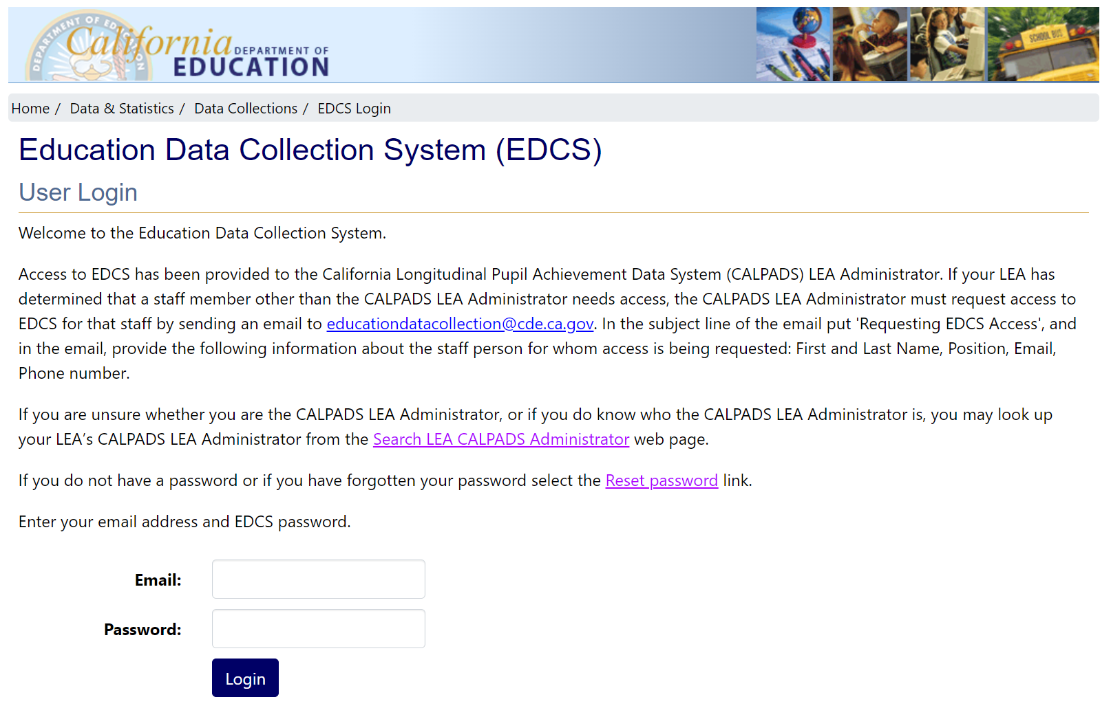

On the Reset Password page, enter your email address and click the ‘Submit’ button.

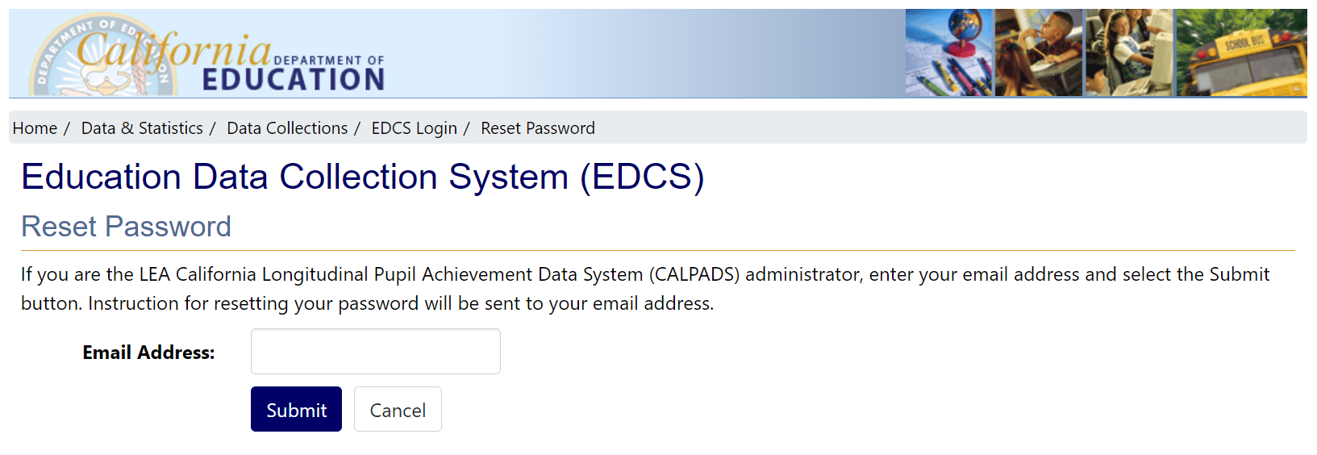

If you are the CALPADS LEA Administrator, or if your CALPADS LEA Administrator has requested access for you, after submitting your email, you will see the “Reset Password” page, shown below, that has the message, “An email has been sent to your email address. Please follow the instructions in your email.”

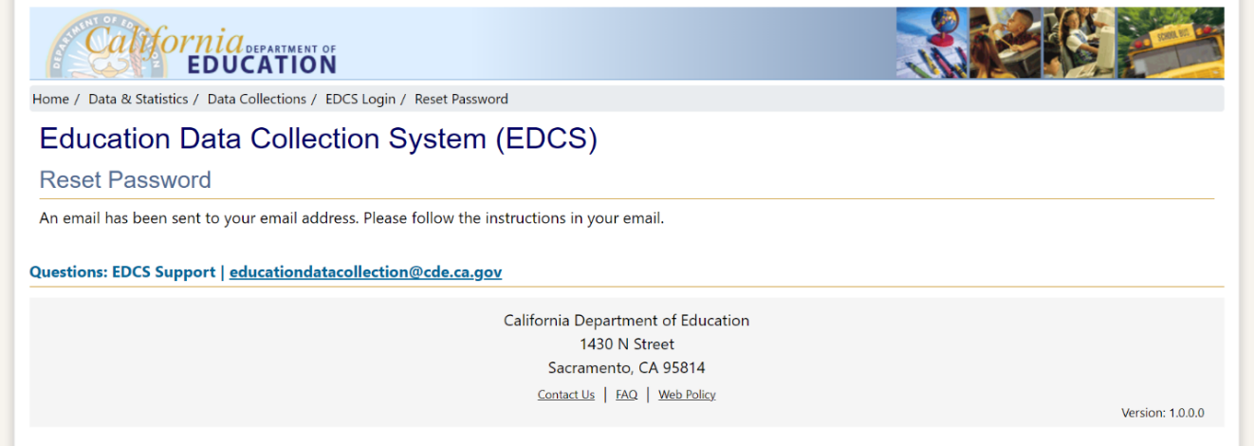

**If you are NOT the CALPADS LEA Administrator**, or if your CALPADS LEA Administrator has not requested access for you, you will see the “Reset Password” page shown below that has the message that starts with “Password reset failed.”

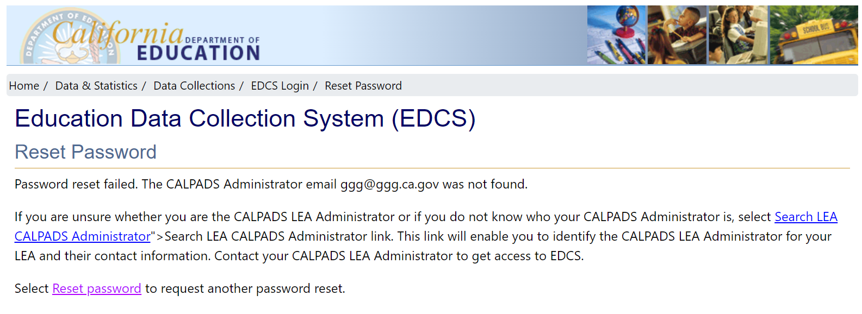

If you are unsure whether you are the CALPADS LEA Administrator, or if you do not know who your CALPADS Administrator is, utilize the "Search LEA CALPADS Administrator" link provided on the Education Data Collection System Search page at <https://www2.cde.ca.gov/edcollectionsystem/search>. A search will enable you to identify the CALPADS LEA Administrator for your LEA, and it should include their contact information.   
Contact your CALPADS LEA Administrator to get access to EDCS.

After submitting your email, if you have access to EDCS, you will receive an email that looks like this:

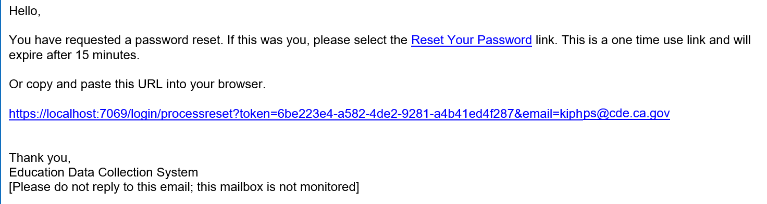

To set/reset your password, you can either select the “Reset Password” link or copy and paste that same URL into your browser.

Once you click on the link provided in your email, your browser should open to the screen shown below, prompting you to input a new password and confirm it. Make sure to adhere to the password requirements provided. Finally, click the ‘Submit’ button to proceed.

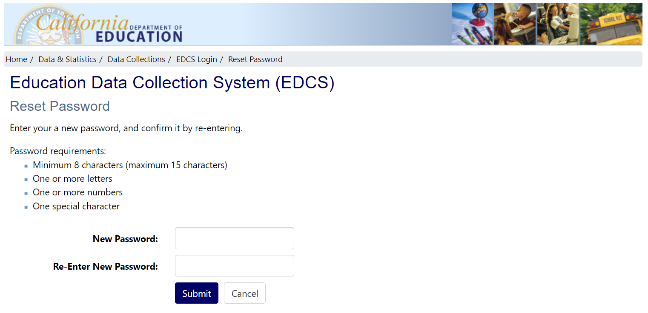

Upon clicking the ‘Submit’ button, you will receive a message "Password reset complete." Next, click on the login link provided, and you will be returned to the EDCS login page.

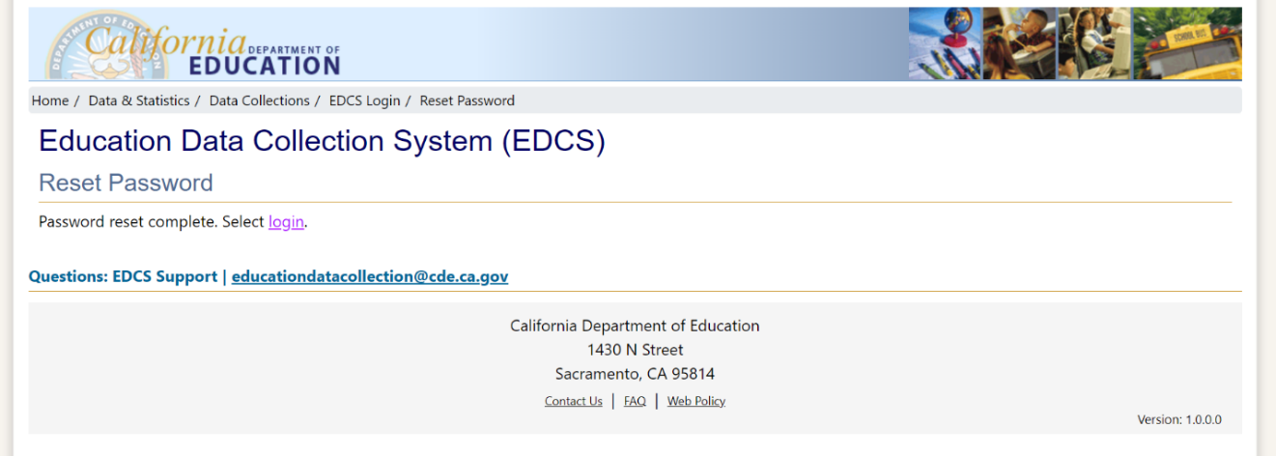

### Login – With Password

From the User Login page, shown below, proceed by entering your email address along with your password, and then click the ‘Login’ button.



Once you have successfully logged in, you will be directed to the EDCS Programs page.   
From there, proceed by selecting the SSCE program.

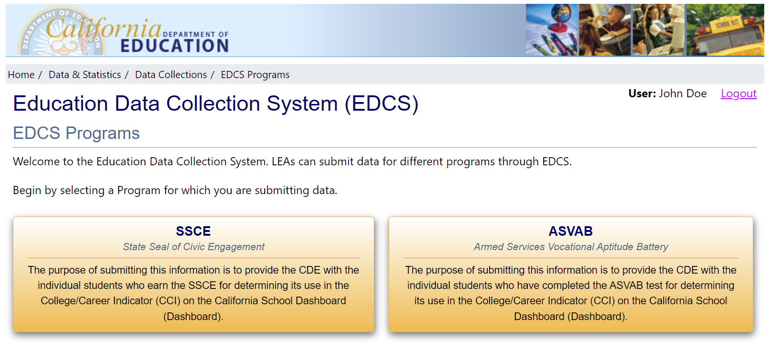

Upon selecting the SSCE program, you will be redirected to the SSCE Dashboard page, shown below. From there, use the drop-down menu to select your LEA.

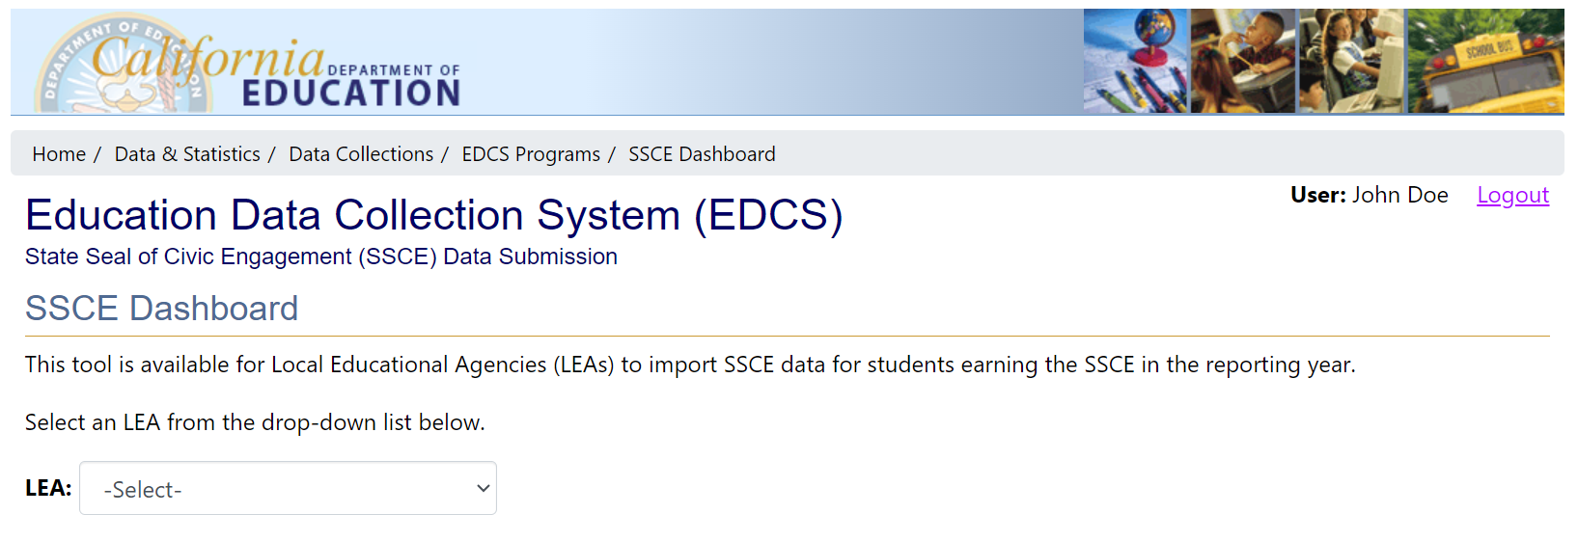

Once you have selected your LEA, the SSCE Dashboard page will refresh automatically. If there are any Active or Archived submissions, they will be displayed on this page. To initiate the import of SSCE data, simply click the ‘Import SSCE Data for 2023–2024’ button.

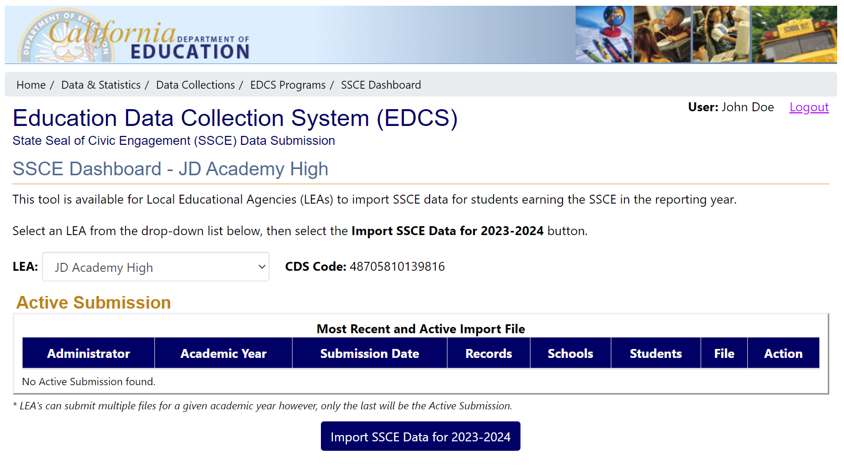

After clicking the ‘Import SSCE Data for 2023–2024' button, the SSCE Import page with Import Instructions, shown below, will appear. Please read the instructions carefully. Then, proceed by clicking the ‘Choose File’ button to select an import file that you have already created. For instructions on creating your SSCE import file, refer to the SSCE Instructions found on the SSCE Instructions page at <https://www2.cde.ca.gov/edcollectionsystem/ssce/instructions>

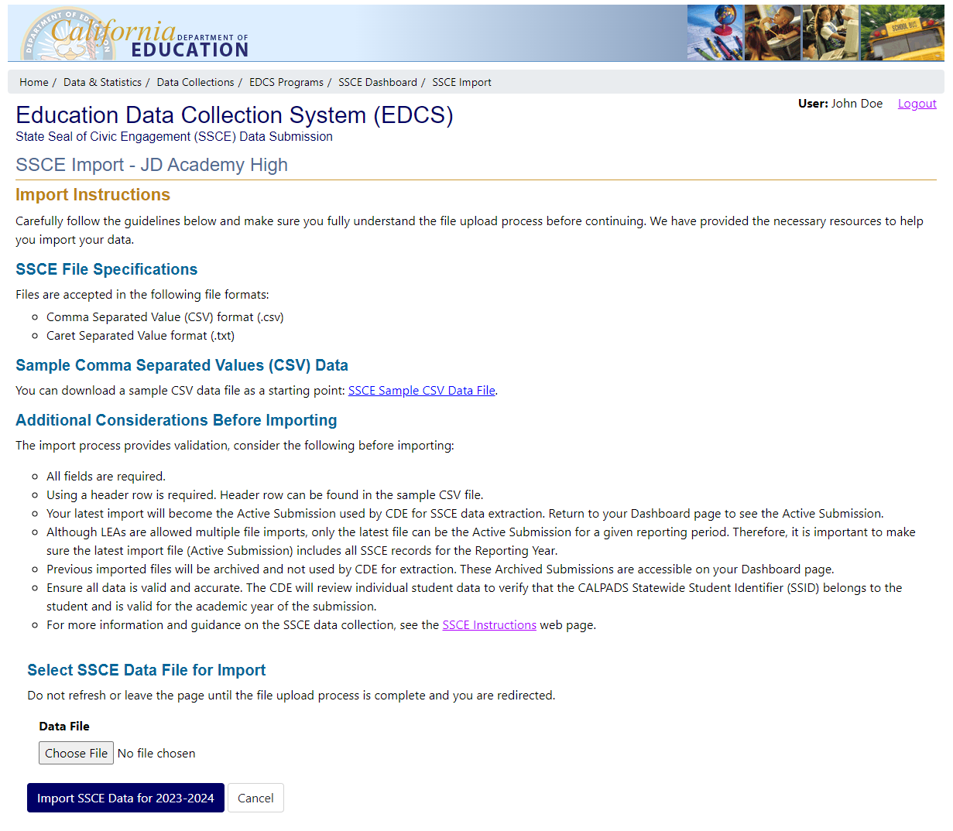

Upon selecting the ‘Choose File’ button, the Windows Open dialog box, shown below, will appear. Navigate to your import file within this dialog box, and select it. Once you have selected your import file, and once the dialog box closes, you will see the file name of the selected file displayed.

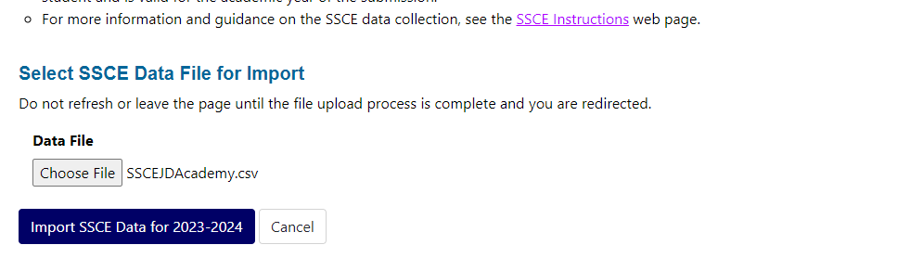

Once you have selected your file, proceed by clicking the ‘Import SSCE Data for 2023−24’ button. EDCS will then begin importing your file. If your file passes all validations, you will receive a message stating “Import was successful” as shown below. However, if there is something wrong with how the file is formatted or an issue with data in the file, you will receive error messages. The error message will list the rows which contain errors, and the types of errors found. You will need to correct all the errors and repeat the import process. The “Import Error Examples” section below provides examples of error types and how to resolve them.

Once the import process has been successfully completed, click the “Back to Dashboard” link. This will navigate you back to the SSCE Dashboard page.

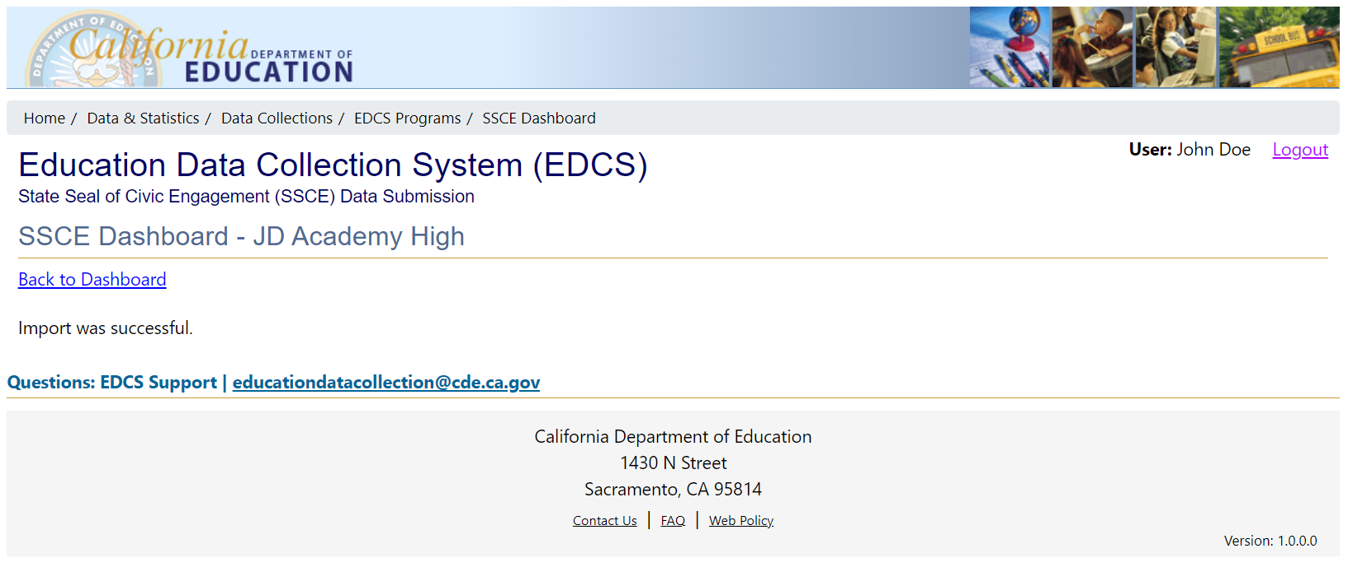

The SSCE Dashboard page shown below, displays:

* In the “Most Recent and Active Import File” table, under Active Submission, the file that the California Department of Education (CDE) will extract and use once the submission closes
* In the “Import File History” table, under Archived Submissions, all the previously imported files that are now archived.

On this page, verify that the “Most Recent and Active Import File” table contains your latest import and confirm the counts of Records, Schools, and Students.

Note that the SSCE file is processed as a full replacement file. This means that the file displayed in the “Most Recent and Active Import File” table will always display the most recent file you imported, and this is the file that CDE will extract once the submission closes. The CDE assumes that this file reflects your LEA’s full and complete set of SSCE data for all schools. That is why it is important that one person is responsible for importing SSCE data for all schools in the LEA; if files are imported by staff at each school, each file imported will override a file previously imported by a staff person at a different school.

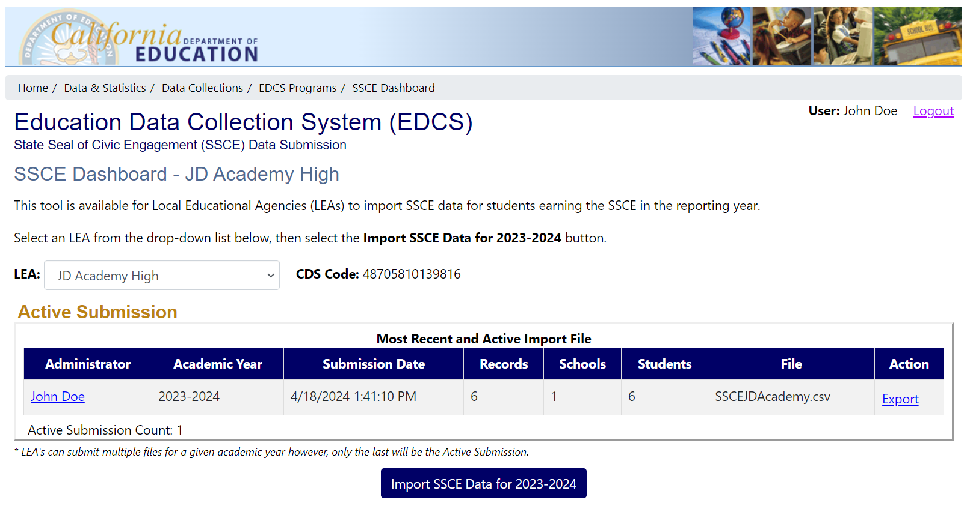

If you have successfully imported a file, and now have an active file displayed in the “Most Recent and Active Import File” table on the SSCE Dashboard, but later discover that your file is incomplete or contains errors in the data that would not be caught by the EDCS validations, you can import a new file that includes the additional data or corrections by following the same steps outlined above. When you import the updated file, the previous active import file will be archived, and the latest file imported will become the active file.

Please note that you can only have one Active import file, and only the active import will be utilized by the CDE.

The SSCE Dashboard shown below displays one active and one archived submission.

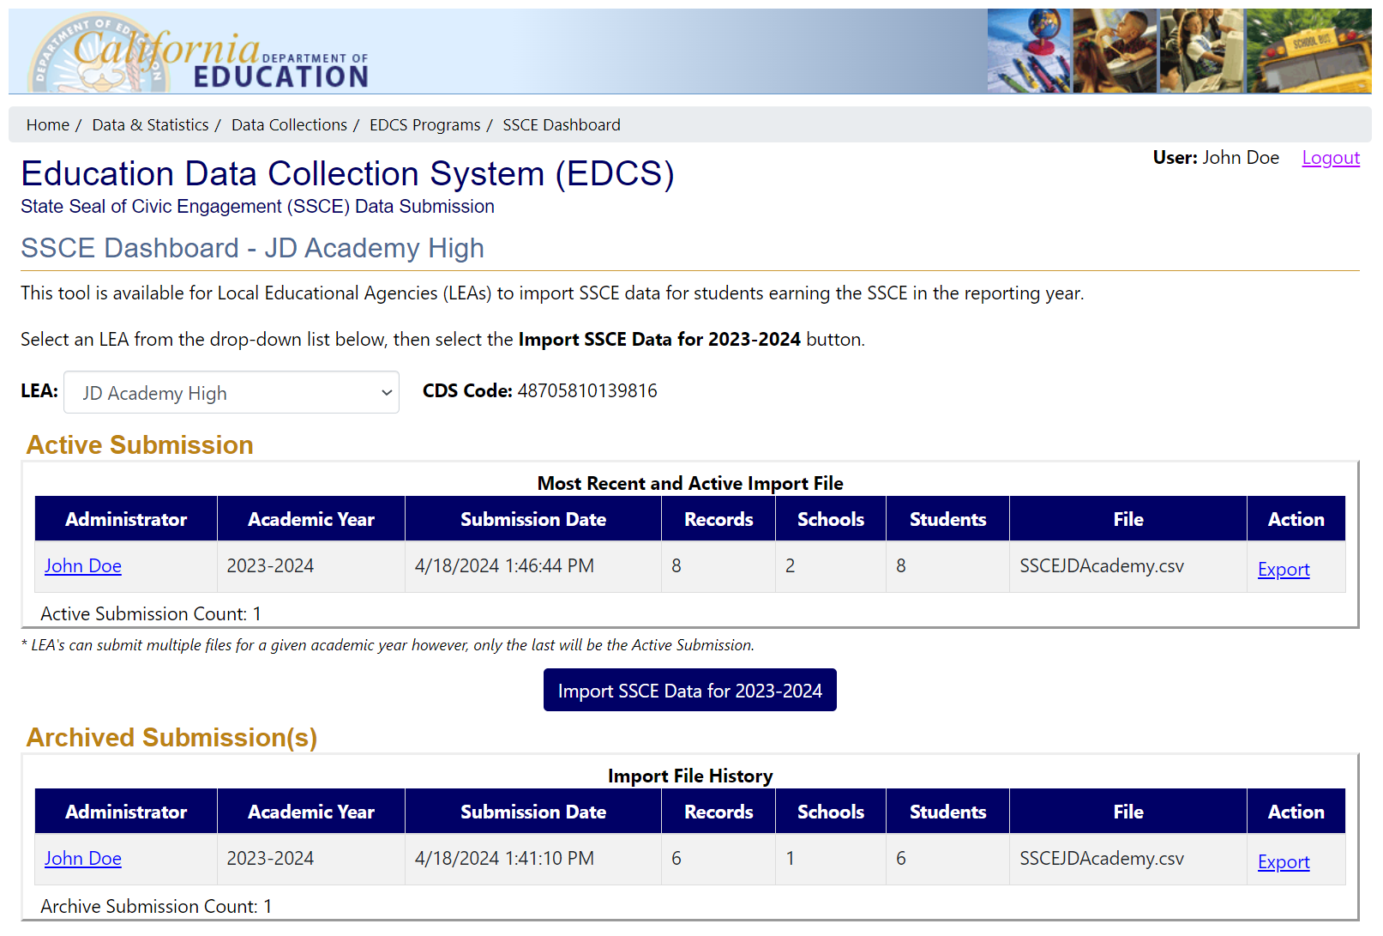

## Import Error Examples

### Validations

All fields are required. The EDCS will validate that:

* The file has a header row.
* Each field in the file is populated.
* There are no blank rows.
* There are no duplicate Statewide Student Identifiers (SSIDs) or Local Student IDs.
* The academic year is populated with 2023−24 (the reporting year).
* The 14-digit California District School (CDS) Code is a valid code.
* The grade level is 11 or 12.
* The document type field is populated with a valid code of D, T, C or G (Diploma, Transcript, Certification of Completion, General Education Development (GED) Certificate).

NOTE: When the submission window closes, the CDE will extract the file in the “Most Recent and Active Import File” table and will then check that each SSID is valid, and that the student was enrolled in the LEA submitting the data. Any invalid SSIDs, or SSIDs for any students not enrolled in the LEA submitting the data, will not be used.

### How to Fix Errors

This section demonstrates how to fix these 7 errors:

* Error 1: Missing header record
* Error 2: Invalid CDS code
* Error 3: Incorrect Academic Year
* Error 4: Missing grade level
* Error 5: Invalid document type (missing document type)
* Error 6: Invalid document type
* Error 7: Duplicated SSID

After addressing the first error of a missing header row, **LEAs can fix the remaining six errors in the file at one time, and then import the new file with all errors fixed.** However, todemonstrate how to fix each error, for illustrative purposes only one error is fixed at a time, and after each error is fixed, the file is re-imported. A new file is then displayed showing the data with the error fixed, and a new error message that includes the remaining errors in that file.

This is the file with 7errors:

**File:** 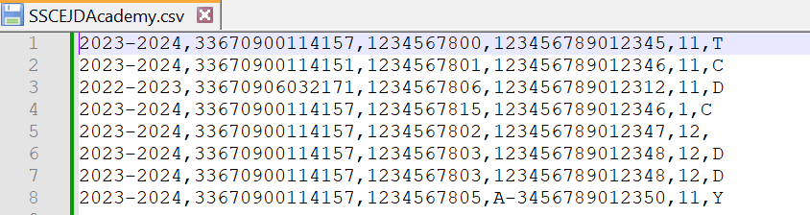

**FIXING ERROR 1:** Missing header record

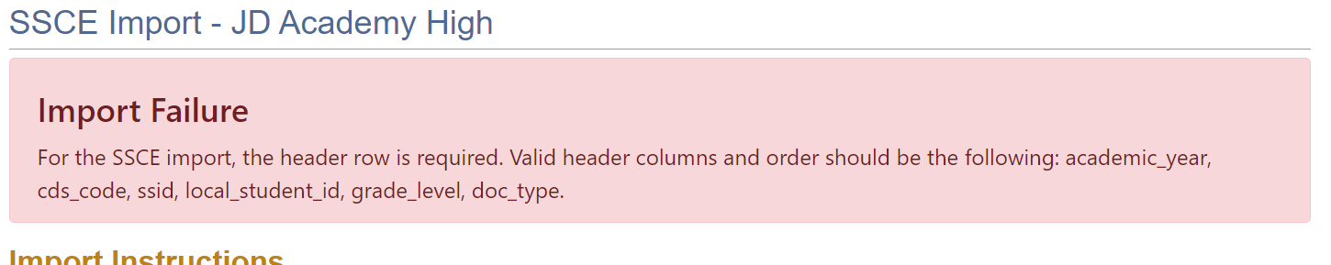 **Correction**: Correct by adding header record.

**New file with header record (highlighted in yellow in the screenshot):**

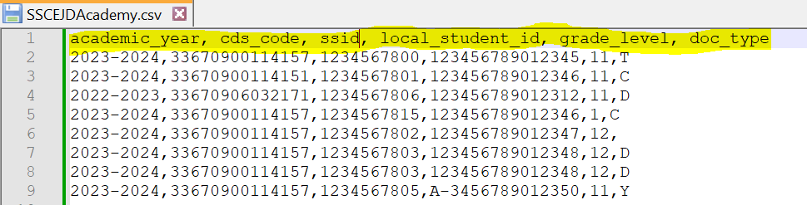

**File Reimported:**

**FIXING ERROR 2:** In row 3, there is an invalid cds_code.

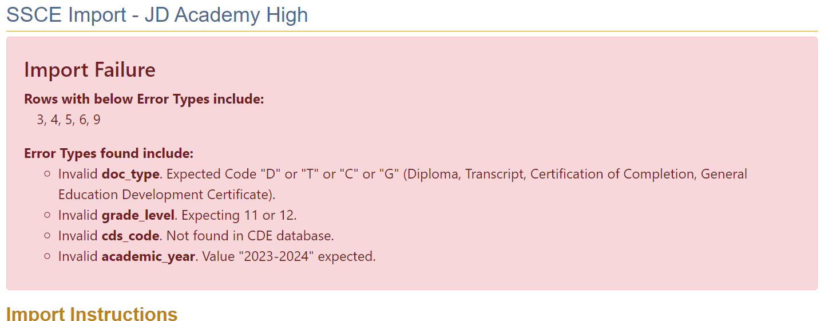

**Correction**: Correct cds_code to a valid code.

**New file with corrected CDS code (highlighted in yellow in the screenshot):**

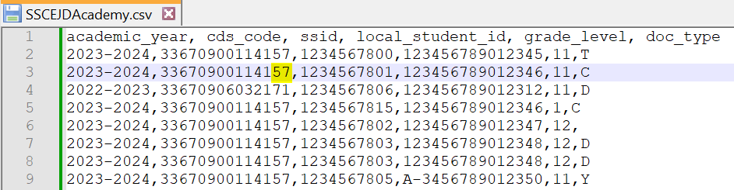

**File reimported:**

**FIXING ERROR 3:** In row 4, there is an invalid academic_Year (for the 2023−24 reporting year the academic year must be 2023-2024)

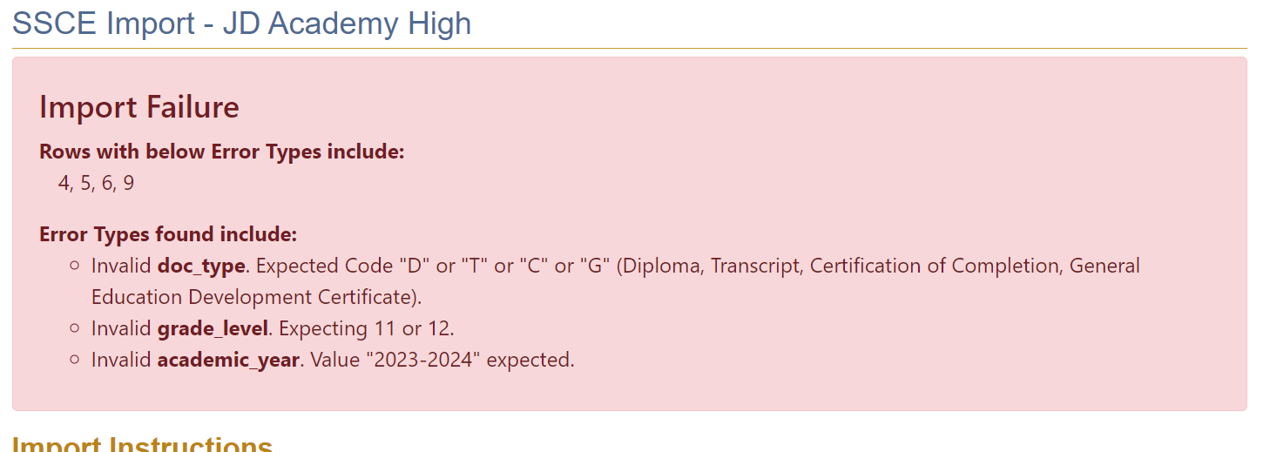

**Correction**: Correct academic_year to 2023–2024.

**New file with corrected academic year (highlighted in yellow in the screenshot):**

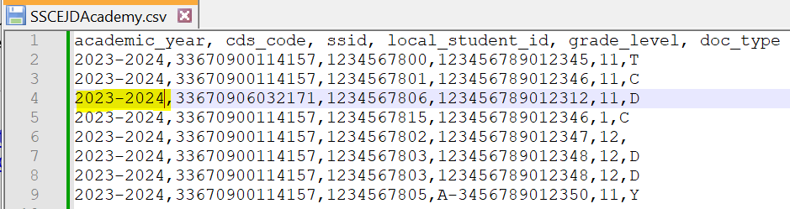

**File reimported:**

**FIXING ERROR 4:** In row 5, there is an invalid grade_level. Grade level must be 11 or 12.

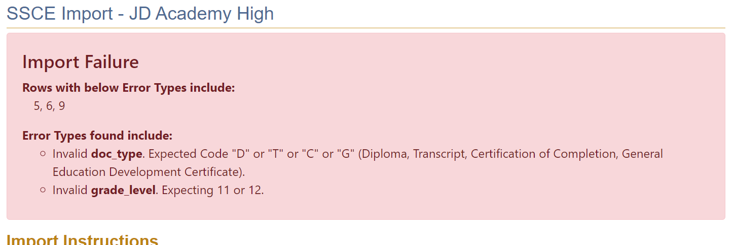

**Correction**: Correct grade_level to correct grade.

**New file with valid grade level (highlighted in yellow in the screenshot):**

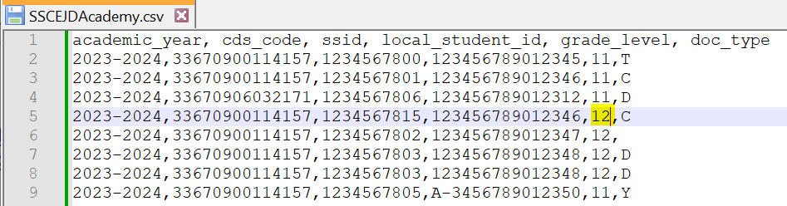

**File reimported:**

**FIXING ERROR 5:** In row 6, the doc_type is missing. All fields are required**.**

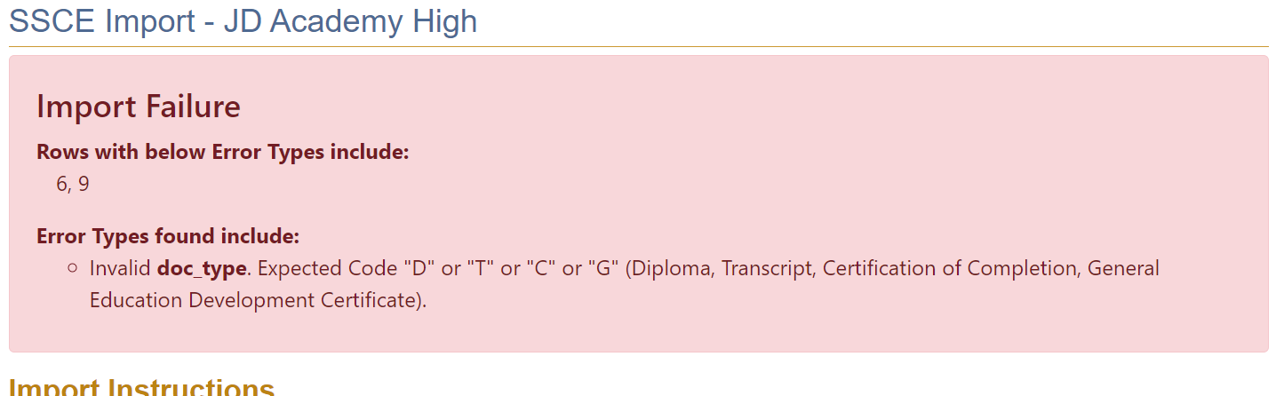

**Correction**: Correct doc_type by populating field with a valid code.

**New file with a valid doc type code added (highlighted in yellow in the screenshot):**

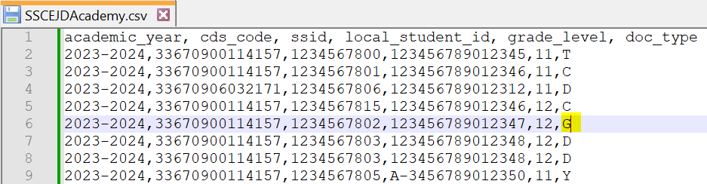

**File reimported:  
  
FIXING ERROR 6:** In row 9 there is an invalid doc_type**.**

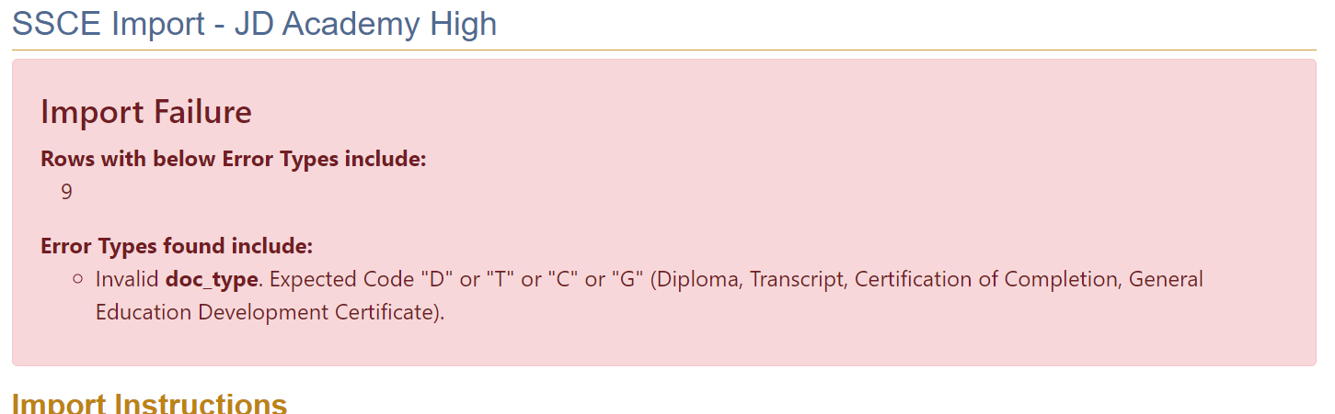

**Correction**: Correct doc_type to a valid code.

**New file with doc_type changed to a valid code:**

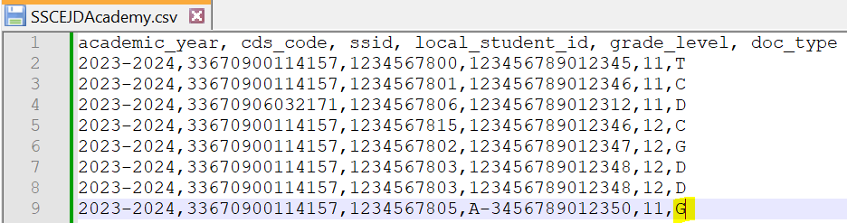

**File reimported:**

**FIXING ERROR 7:** In row 7 and 8 there are duplicate SSID values.

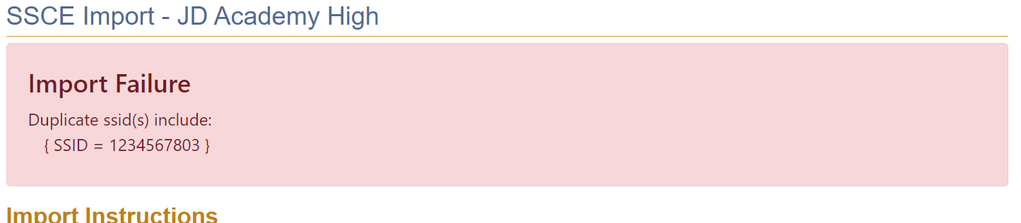 **Correction**: Correct SSID in one of the rows.

**New file with corrected SSID (highlighted in yellow in the screenshot):**

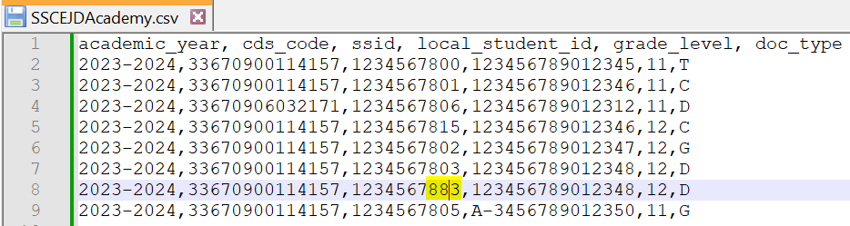

Once all errors have been fixed, import the new file. If the file import is successful, you will receive the message “Import was successful” as shown below. Select the “Back to Dashboard” link to confirm.

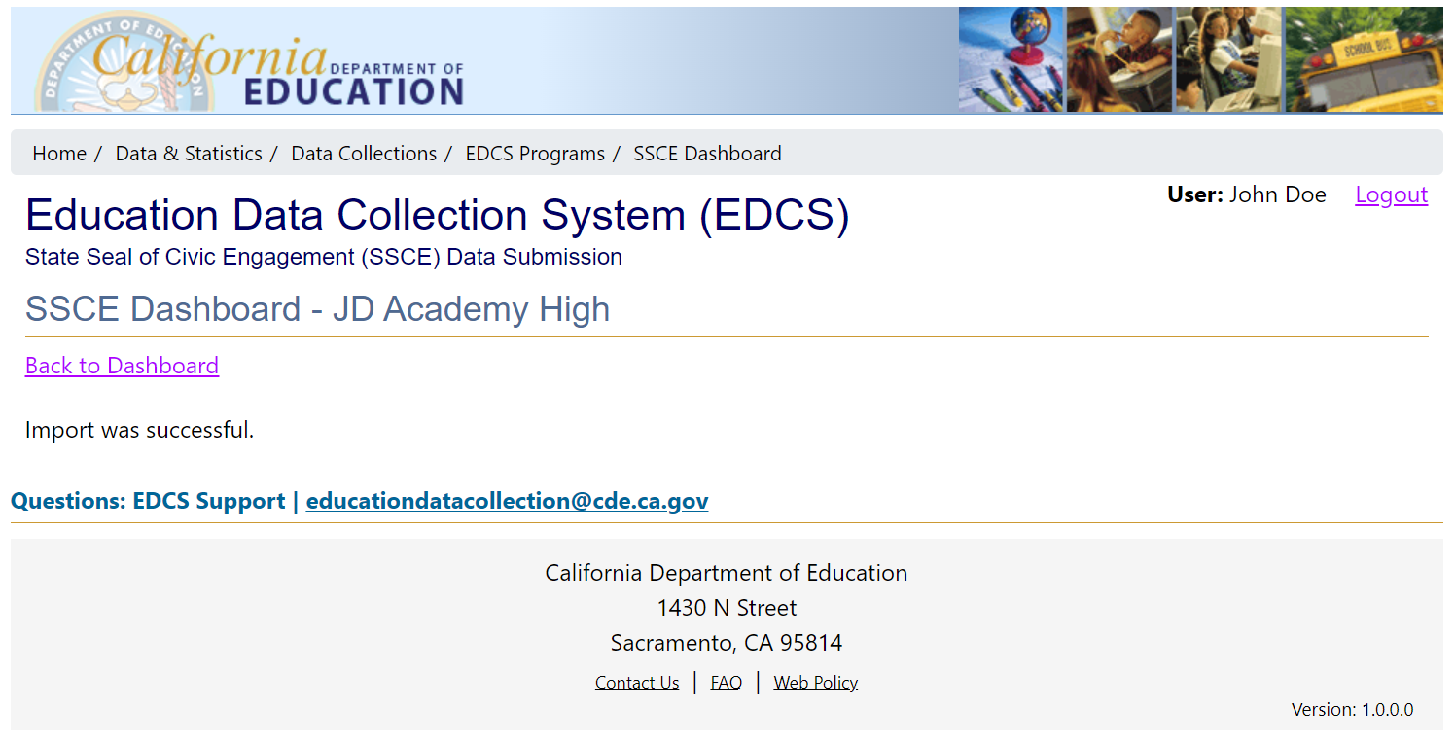

From the SSCE Dashboard page, you will find the file that you just imported, in the “Most Recent and Active Import File” table under Active Submission. You will also see the file that was replaced in the “Import File History” table under Archived Submissions. In the example below, three files have been imported.

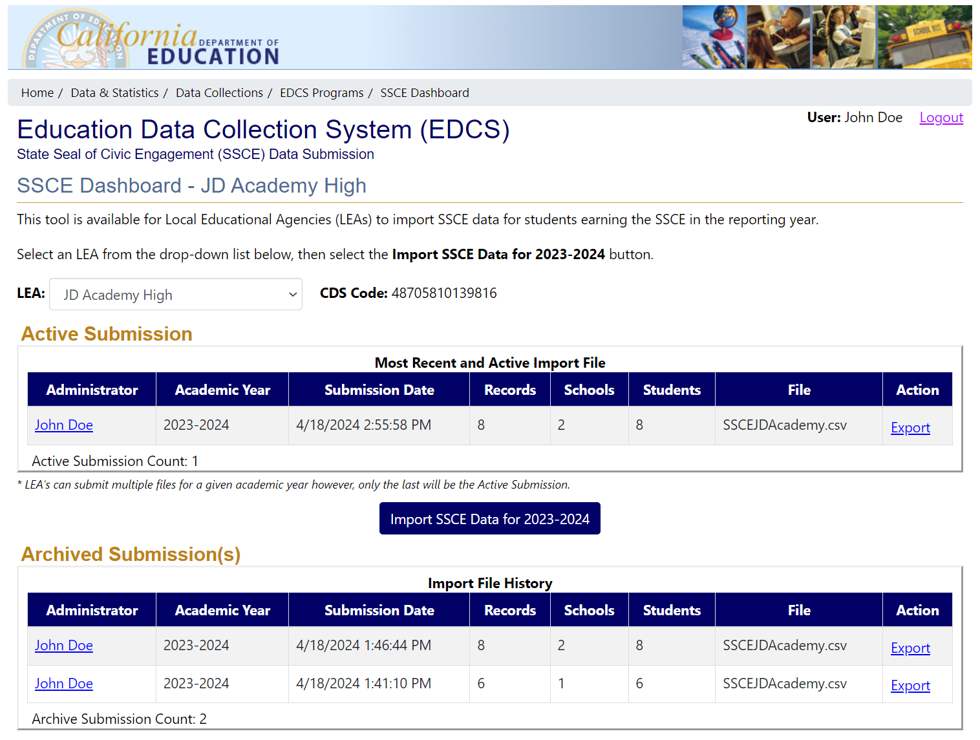

- End of Instructions -